Login Page Details:

Technologies: Node.js, Handlebars, Mongoose, Express.js

Database: MongoDB

Require Database: MongoDB(Please install Mongodb on your pc).

**MongoDb database name :-> loginapp**

**Collection name :-> users**

**Use ORM Mongoose**

**Server Run on port No. 1000**

Step to Run 🡺

1. Open cmd
   1. mongod Enter
   2. 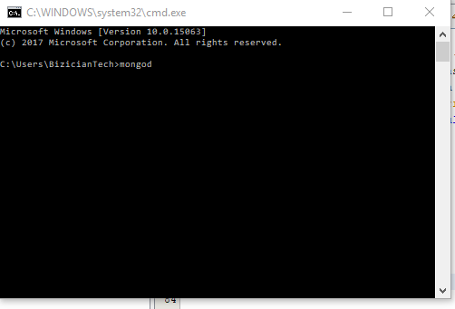
2. Open another cmd
   1. mongo Enter
   2. 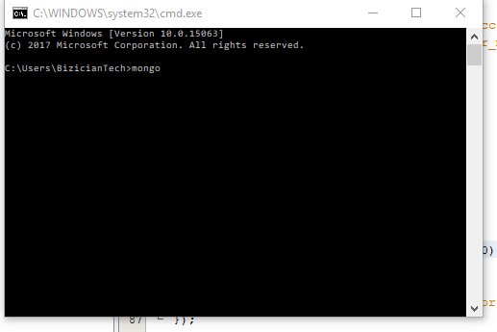
3. open cmd to run Node.j
4. use cd and go to the project directory
5. Enter
6. Type 🡺 npm install // its install the dependencies which is use in the project
7. Then 🡺 node app.js
8. Open the browser and type🡺 localhost:1000

Login Page:

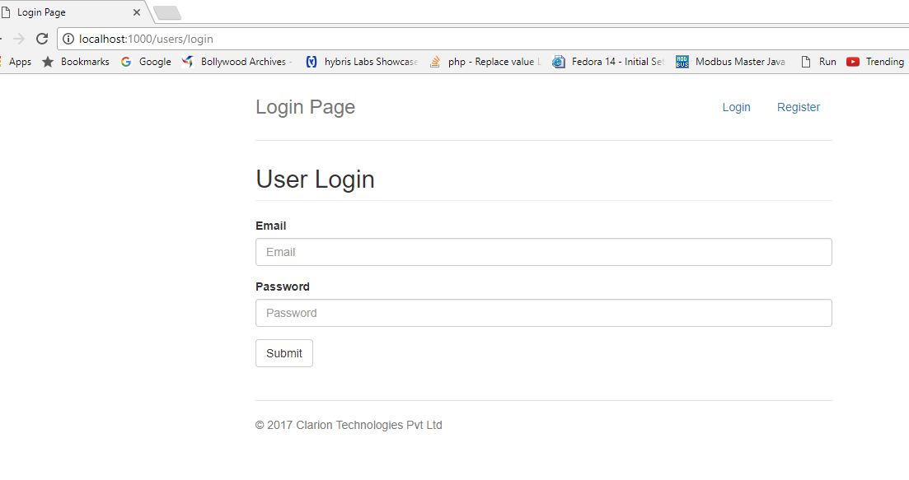

Register page:

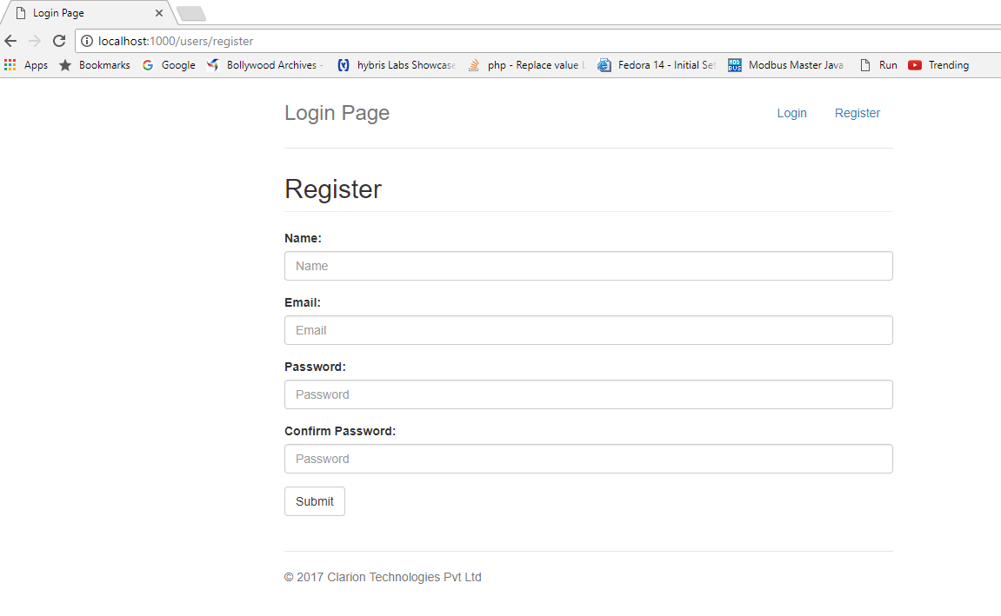

Register a new user:

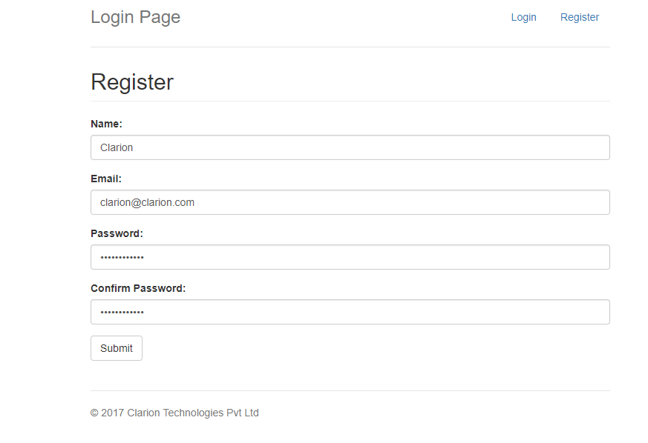

After successful registration it navigates to login page:

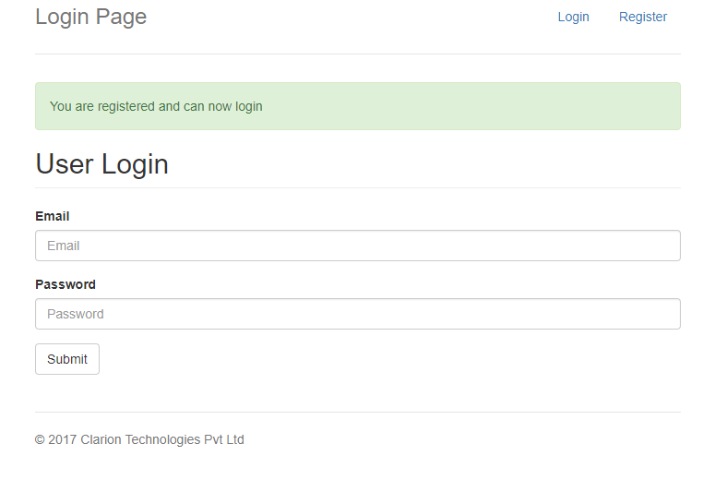

Login Email: [clarion@clarion.com](mailto:clarion@clarion.com)

Password: [Clarion123](http://clarion@clarion.com/Clarion123)

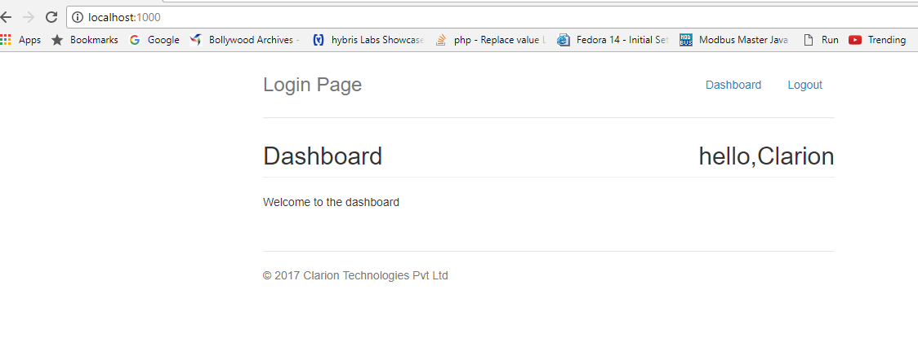

Note: Please run the mongoDB server.

Thanks:

Rahul kumar Prajapati

[Mr.rahulkprajapati@gmail.com](mailto:Mr.rahulkprajapati@gmail.com)

+91- 9552955960